Jeziel E. Torres Vazquez

INEL 4998 (Investigation Course)

Prof. Eduardo Ortiz

Week: February 1-5

In this week, the OpenDss teams made a meeting to discuss the assigned webinars from HeatSpring that talk about OpenDss and the Distribution Impact Analysis. This task was assigned by Angel Ortiz to all the OpenDss members. I watch the assigned webinars from HeatSpring. There were 3 webinars and another webinar that was this week on Thursday. The webinar from HeatSpring that I watch where the ones marked in green checkmarks.

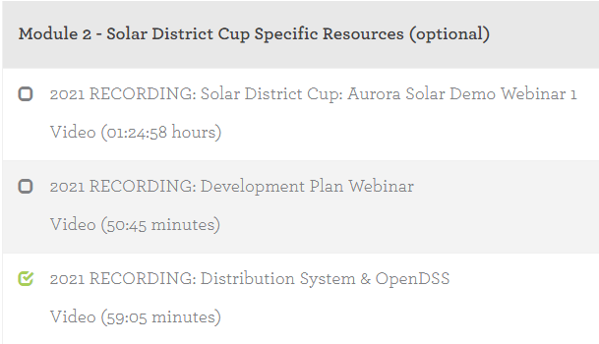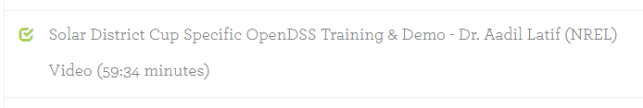

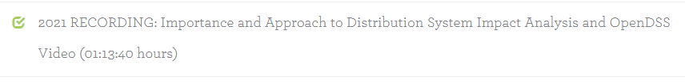

All webinars were presented by Dr. Latif because he is the expert on OpenDss and the Distribution Impact Analysis. Latif talks about how OpenDss helps simulated the circuit and controls more the approach to make a better system overall. On one of the webinars, he talks more in depth on all the different components that can be utilized and created in OpenDss. Specifically, he talks about PV, transformer, lines, inverter, and battery bank. This was the most important component for our research and for the competition. The most important one for the team was the battery and the inverter because we need to figure out how those components need to get connected to the circuit. This task is going to be done later in the semester, for now the team wants to concentrate on making faster the approach of binding the existing code with the parameters the design team is going to give us. 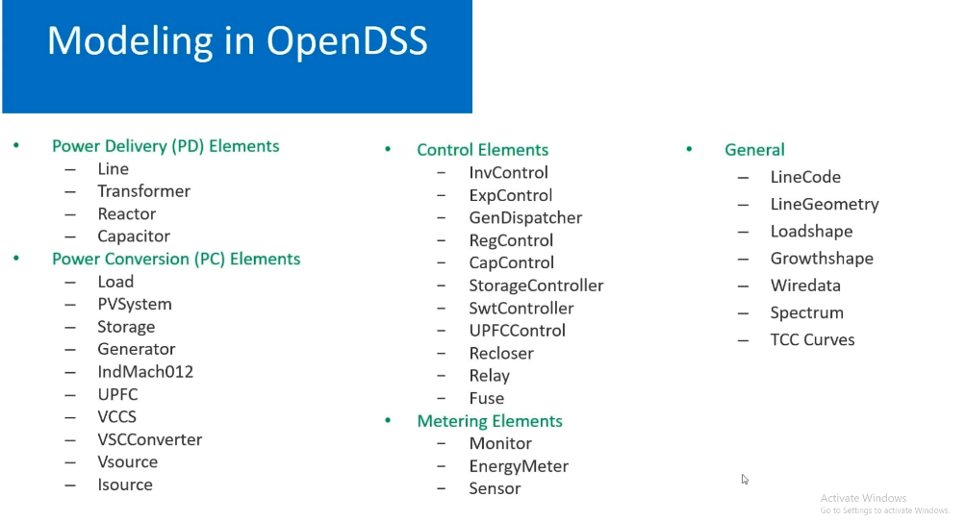



In the meeting we discuss and talk about the webinars. We explain and discuss how they would help us in our part of the research and how we could implement more components to stabilize and make perform better the system overall. We were tasked to think and make a new approach to the coding part of the competition in OpenDss. In the meeting we talked about how we could improve coding and making everything faster and more efficient for us. This refers to making a system for OpenDss that can be changed with less or any repercussion. This was our task for next week. Think of any way to have coding faster and better if there are any changes with the Design Team or in the system in general.